Apple Bowl

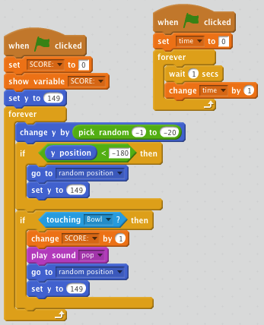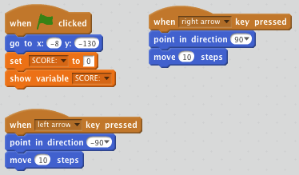1)Upload a background.

2)Upload the apple sprite.

3)Upload the basket sprite.

4)Code to move the basket sprite.

5)Code for the apple falling.